Prescription Drugs

- What is prescription misuse?
  - Taking a medication other than prescribed.
  - Taking someone else’s prescription.
  - Taking a medication to feel euphoria (i.e., to get high).
- Types of prescription medications
  - Stimulants
    - Adderall (amphetamine salts, amphetamine)
    - Ritalin
    - Vyvanse
    - Concerta
  - Opioids (narcotics)
    - Oxycontin (oxycodone)
    - Lortab (hydrocodone & acetaminophen)
    - Percocet (oxycodone & acetaminophen)
    - Fentanyl
  - Benzodiazepines
    - Xanax (alprazolam)
    - Valium (diazepam)
    - Ativan (lorazepam)
    - Klonopin (clonazepam)
- Signs of drug overdose
  - Stimulants
    - Agitation
    - Increased body temperature
    - Hallucinations
    - Convulsions
  - Narcotics/Depressants
    - Cold, clammy skin
    - Slow or shallow breathing
    - Extreme drowsiness
    - Convulsions
- Exhibiting ANY ONE of these symptoms is a sign of overdose. It’s important that when someone is showing these signs they need assistance. Follow these steps to take care of your people. Remember, Vols Help Vols
  - Call 911
  - Stay with the person
  - Lay them on their side

- Keeping Your Prescriptions Safe
  - Monitor
    - Take note of how many pills are in each of your prescription bottles or pill packers, and keep track of refills.
  - Secure
    - Secure them in a place only you know about, preferably locked.
- Steps for the appropriate use of your prescription medications
  - Follow directions as explained on the label or by the pharmacist.
  - Be aware of potential interactions with other drugs as well as alcohol.
  - Speak with a doctor before changing a dosing regimen.
  - Store your prescription safely.
- Alcohol & Drug Interactions
  - Combining medications (prescribed or not prescribed) with alcohol can have unpredictable and unwanted consequences.
  - Some medications—including many popular pain medications and cough, cold, and allergy remedies—contain more than one ingredient that can react with alcohol. Read the label on the medication bottle to find out exactly what ingredients a medicine contains.
  - Mixing alcohol and medicines puts you at risk for dangerous reactions. Protect yourself by avoiding alcohol if you are taking a medication and do not know its effect. To learn more about a medicine and how it will interact with alcohol, talk to your pharmacist or other health care provider.
- Disposal/Collection of Drugs
  - The goal of the collection is to prevent prescription and over-the-counter medications from getting into the waterways, into the hands of children, and to make sure they are disposed of in a safe, environmentally-friendly manner.
  - Find a Prescription Drug Take-Back Box
    - https://apps2.deadiversion.usdoj.gov/pubdispsearch/spring/main?execution=e2s1
  - Permanent Drop Boxes on campus
    - UTPD at 1101 Cumberland Ave
    - Student Health Center Pharmacy at 1800 Volunteer Blvd
  - Acceptable items for Permanent Drop Box
    - Unwanted, outdated, and expired prescriptions and over-the-counter medications
    - Veterinarian prescribed pet medications
- Resources: On Campus
  - Center for Health Education & Wellness (CHEW) http://wellness.utk.edu
    - Vols Know Prescription Stimulants
      - A program that provides information on prescriptions stimulants, how to recognize them, understand misuse, and correct misperceptions.
  - University of Tennessee Police Department (UTPD) http://utpolice.utk.edu
    - Lost & Found. To inquire about a lost item contact UTPD at 865-974-3114
  - Student Health Center Pharmacy http://studenthealth.utk.edu/student-health-center-pharmacy/
    - The Student Health Center Pharmacy is the only pharmacy located in the heart of UTK campus.
  - Student Counseling Center http://counselingcenter.utk.edu
    - The Student Counseling Center is the university’s primary facility for personal counseling, psycho-therapy, and psychological outreach and consultation services. Our mission is to promote the psychological, educational, and social well-being of the student of the University of Tennessee and to help prepare them to be productive members of society. The Student Counseling Center provides the following services for students:
      - Brief Consultation Session
      - Individual, Couples, Group Counseling and Psychotherapy
      - Crisis Services
      - Psychiatric Services
      - Psychoeducational Workshops and Consultations
      - Referrals to on- and off-campus mental health services
- Additional Resources: Off Campus
  - Knoxville Police Department (KPD)
    - Unwanted Medicines Collection
  - Metro Drug Coalition (MDC) https://metrodrug.org/
    - MDC is a nonprofit organization established 31 years ago by a joint resolution of City of Knoxville and Knox County to unite policy makers and leaders to address community substance abuse issues.
  - Cornerstone of Recovery https://www.cornerstoneofrecovery.com/
    - Provides treatment to individuals and their families to address substance use disorders. Cornerstone provides medical detox, residential, intensive outpatient, outpatient, and support living programs.
  - Centerpointe http://www.mcnabbcenter.org/location/centerpointe
    - A program of Helen Ross McNabb Center that provides alcohol and drug residential services as well as medical detoxification and a crisis stabilization unit.
  - Peninsula Lighthouse and Outpatient Clinic https://www.peninsulabehavioralhealth.org/outpatient/
    - Provides intensive outpatient programs for substance use disorders as well as outpatient therapy services.

- Images you can use
  - What to do:
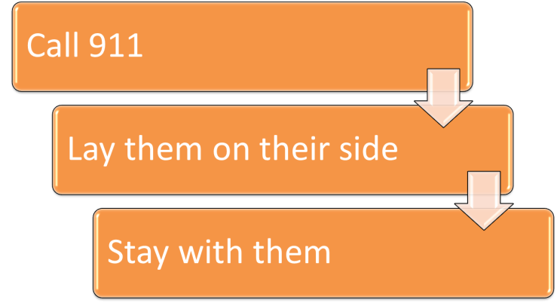

References
https://www.drugabuse.gov/publications/research-reports/misuse-prescription-drugs/how-can-prescription-drug-misuse-be-prevented
https://www.drugabuse.gov/publications/research-reports/misuse-prescription-drugs/summary
https://www.drugabuse.gov/drugs-abuse/prescription-drugs-cold-medicines
https://drugfree.org/article/secure-dispose-of-medicine-properly/
https://pubs.niaaa.nih.gov/publications/medicine/medicine.htm
http://www.knoxvilletn.gov/government/city_departments_offices/public_service/solid_waste/unwanted_medicines_collection

