Know the Standard (Alcohol Education)
- Standard Drink
  - The National Institute on Alcohol Abuse and Alcoholism (NIAAA) states that different drinks contain different amounts of alcohol. It is important to know how much alcohol is in a drink. In the United States, one “standard drink” contains roughly 14 grams of pure alcohol. The following drinks all have this amount of alcohol and are considered “standard drinks.” The percentages are the amount of pure alcohol in these beverages. It is represented as alcohol by volume, or ABV.
    - 12 oz. beer or spiked seltzer (3-5% ABV)
    - 5 oz. wine (12-15% ABV)
    - 1.5 oz. shot (40% ABV)
- Binge Drinking
  - According to the National Institute on Alcohol Abuse and Alcoholism (NIAAA), binge drinking is defined as 5 drinks or more within two hours for men and 4 or more drinks within two hours for women.
- Heavy Drinking
  - The Substance Abuse and Mental Health Services Administration (SAMHSA) states that binge drinking on any five or more days in the past 30 days is heavy drinking.
- Factors that Impact your Blood Alcohol Concentration/Content (BAC)
  - Weight
  - Biological sex
  - Number of standard drinks
  - Rate of consumption
- Signs of Alcohol Overdose
  - Just remember C.U.P.S.
    - Cold Skin
    - Unresponsive
    - Puking
    - Slow Breathing
  - Exhibiting ANY ONE of these symptoms is a sign of alcohol overdose. This doesn’t necessarily mean someone is dying but it is a clear sign of the body trying to communicate to stop putting alcohol in. It’s important that when someone is showing these signs, they should stop drinking and receive assistance. Follow these steps to take care of your people. Remember, Vols Help Vols
    - Call 9-1-1 immediately
    - Stay with them
    - Lay them on their side
    - Do not give them food or water at this point. Doing so can increase the person’s risk of choking or aspirating because they are likely to just puke it up.
  - Additionally, Medical Amnesty is a policy at the University of Tennessee that states a student of concern and the good Samaritan making the call will not receive disciplinary action from the institution. The purpose of this policy is to encourage our students to take care of one another and get help.
- Resources: On Campus
  - Center for Health Education & Wellness (CHEW) http://wellness.utk.edu
    - Volunteers Speak UP! Alcohol Edition
      - Volunteers Speak UP! Alcohol Edition (VSU: Alcohol Edition) is a program that includes information on how to recognize alcohol overdose, care-taking skills for when someone has overdosed on alcohol, how to be an active bystander, and ways to Speak UP! in situations. The program include discussion on specific scenarios related to concerning drinking behavior and drinking and driving.
    - Know the Standard Program (VOLS 2 VOLS)
      - Know the Standard is a program facilitated by the VOLS 2 VOLS Peer Health Educators in CHEW. Know the Standard is about alcohol risk-reduction. We know that drinking is a big responsibility, and if our students are choosing to drink, they should be equipped with information to do so in a safe manner.
    - We Got Your BAC
      - We Got Your BAC is an interactive, activity-based program to provide in-depth information on blood alcohol content. The purpose is to provide accurate information to help individuals who choose to drink to make informed decisions about their health and wellbeing related to drinking behavior.
  - Student Counseling Center http://counselingcenter.utk.edu
    - The Student Counseling Center is the university’s primary facility for personal counseling, psycho-therapy, and psychological outreach and consultation services. Our mission is to promote the psychological, educational, and social well-being of the student of the University of Tennessee and to help prepare them to be productive members of society. The Student Counseling Center provides the following services for students:
      - Brief Consultation Session
      - Individual, Couples, Group Counseling and Psychotherapy
      - Crisis Services
      - Psychiatric Services
      - Psychoeducational Workshops and Consultations
      - Referrals to on- and off-campus mental health services
- Additional Resources: Off Campus
  - Metro Drug Coalition (MDC) https://metrodrug.org/
    - MDC is a nonprofit organization established 31 years ago by a joint resolution of City of Knoxville and Knox County to unite policy makers and leaders to address community substance abuse issues.
  - Cornerstone of Recovery https://www.cornerstoneofrecovery.com/
    - Provides treatment to individuals and their families to address substance use disorders. Cornerstone provides medical detox, residential, intensive outpatient, outpatient, and support living programs.
  - Centerpointe http://www.mcnabbcenter.org/location/centerpointe
    - A program of Helen Ross McNabb Center that provides alcohol and drug residential services as well as medical detoxification and a crisis stabilization unit.
  - Peninsula Lighthouse and Outpatient Clinic https://www.peninsulabehavioralhealth.org/outpatient/
    - Provides intensive outpatient programs for substance use disorders as well as outpatient therapy services.

- Images you can use
  - Standard Drinks:
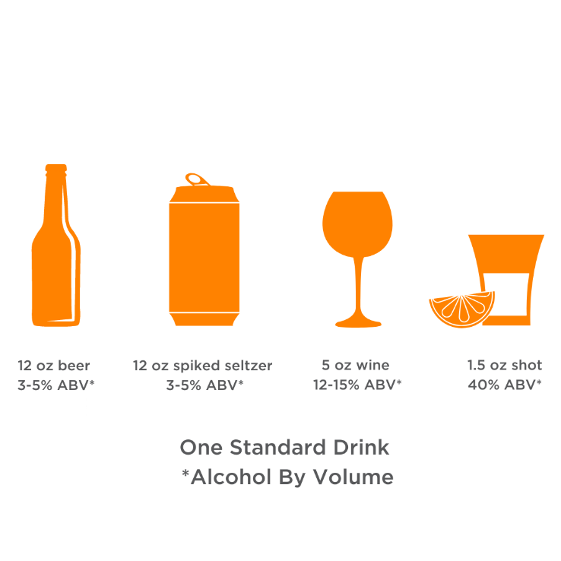

  - Just Remember C.U.P.S.:

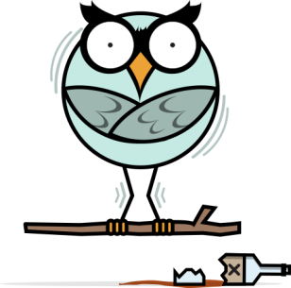 | 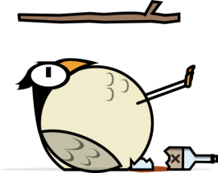
Cold | Unresponsive
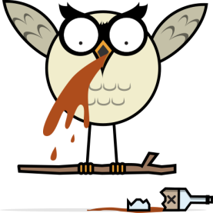
Puking | Slow Breathing

*Images courtesy of Syracuse University (if using these images, please be sure to list this credit)

  - What to do:

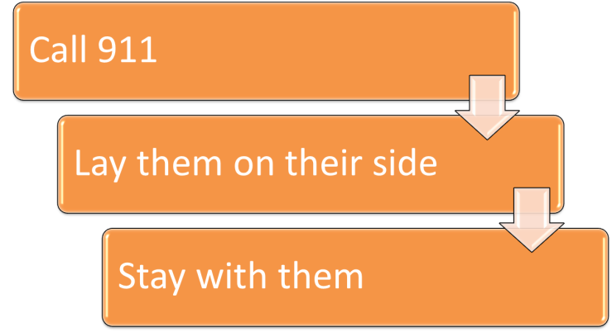

References

https://www.niaaa.nih.gov/alcohol-health/overview-alcohol-consumption/moderate-binge-drinking

https://www.niaaa.nih.gov/alcohol-health/overview-alcohol-consumption/what-standard-drink

https://www.samhsa.gov/disorders/substance-use

