Healthy Relationships

Have you ever tried a jellybean that looked like it would taste like lemon or lime, only to discover it tasted like grass? Sometimes relationships can look okay on the outside but be something that you did not want on the inside. It’s important to know what the characteristics of a healthy relationship and the characteristics of a unhealthy relationship are to be able to know if your relationships are having a positive impact on your life.

What Kind of Relationships Should be Healthy?

Most people assume healthy relationships only refers to romantic relationships. But developing healthy relationships can happen in any relationship.
- Friends
- Family
- Roommates
- Coworkers
- Acquaintances
- Classmates

Know the Signs of Healthy and Unhealthy Relationships

It’s a good sign if your relationship has:

- Independence
  - Both of you take time alone when you need it
  - Neither of you expect the other to give you everything you need.
- Honesty & Accountability
  - Both of you accept responsibility for yourselves, admit when you are wrong, and communicate openly and truthfully
- Respect
  - Is emotionally affirming and understanding, listens non-judgmentally, values your opinions
- Safety & Comfort
  - Ensures you are able to express yourself and able to do the things you want to do
  - Intentionally creates an environment where you feel safe
- Negotiation & Fairness
  - Accepts change and is able to agree to disagree
  - Seeks mutually satisfying resolutions to conflict
- Trust & support
  - Supports your passions and goals
  - Respects your right to your own feelings, friends, activities, and opinions

It’s a not so good sign if your relationship has:

- Economic Abuse
  - Controls access to money and/or takes your money
  - Prevents you from getting or keeping a job
- Coercion & Threats
  - Threatens to embarrass you, leave you, or hurt you and may carry out these threats
  - Threatens to hurt themselves
- Isolation
  - Controls what you do, who you see or talk to, where you go
  - Uses jealousy to justify their actions
- Minimize, Deny, Blame
  - Makes light of abuse or says the abuse didn’t happen
  - Shifts responsibility of abusive behavior and/or may say you caused the abuse
- Emotional Abuse
  - Always puts you down, calls you names, makes you feel bad about yourself
  - Plays mind games, makes you feel guilty
- Intimidation
  - Makes you feel afraid by using looks, actions, or gestures
  - Destroys your property, including your phone
  - Abuses pets

Relationship Quiz
Read the statements listed below. If two or more statements apply to your relationship, congratulations!
Continue to make sure you and your partner work towards having a relationship.

- is supportive of me
- encourages me
- listens to me when I need to talk
- understands I have my own life too
- respects me and my interests
- makes me feel safe and cared for
- communicates openly and kindly
- doesn't expect me to solve their problems

Read the statements listed below. If two or more statements apply to your relationship, it may be time for a relationship checkup. If you feel comfortable, have a conversation with your partner. If you don’t there are many resources on and off campus for support.

- isn't well liked by my friends
- says I am too busy and should make more time for them
- texts or calls all the time
- gets jealous if I do things with other people
- controls what I wear or do
- calls me names and puts me down
- threatens to hurt me or themselves
- makes me feel nervous or anxious

Images You Can Use
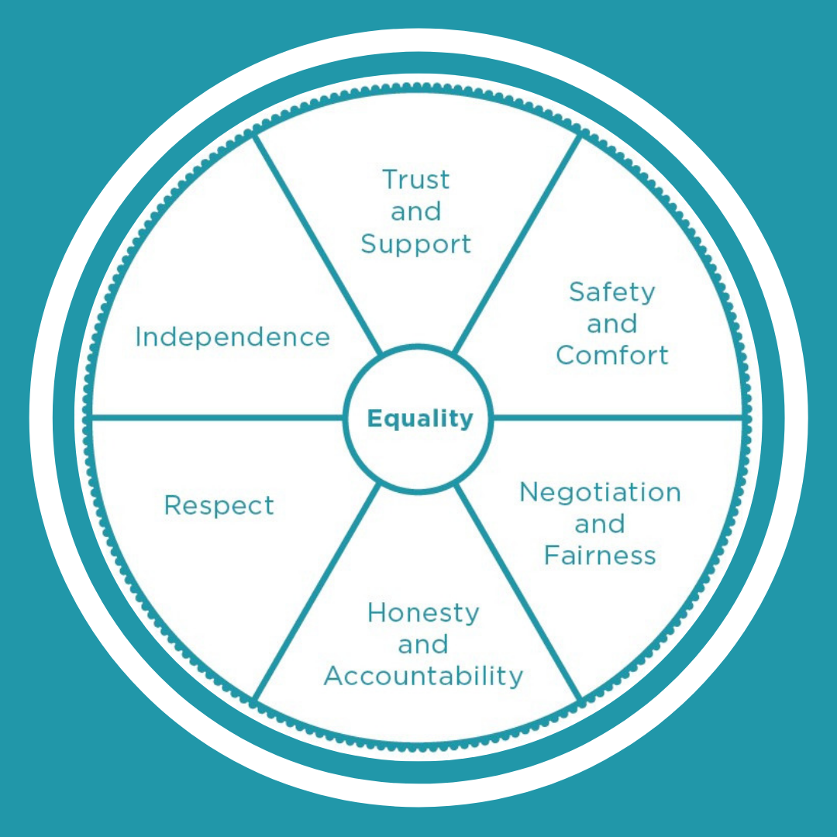

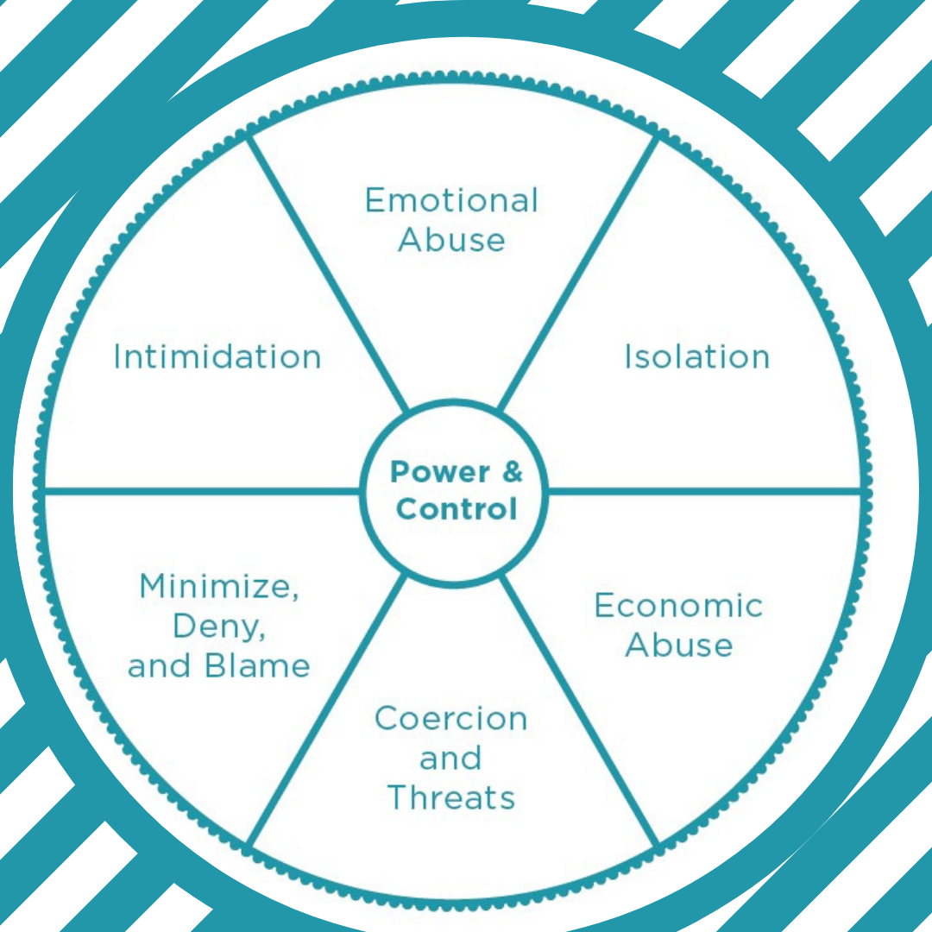

Resources:

On Campus

974-HELP – Dean of Students
413 Student Services Building
1331 Circle Park
Knoxville, TN 37916
865-974-4357

974-HELP is a help line for distressed students. It is available 24hrs a day. If you are concerned or worried for a fellow Vol, observe a behavior that makes you uncomfortable, or you feel like a fellow Vol may harm themselves or others, 974-HELP is where you can call for support. Students can also call 974-HELP for themselves. (It is not a resource for immediate emergencies. Contact 911 or UTPD at 865-974-3111 for emergencies.)

Center for Health Education & Wellness
Student Health Building, 2nd Floor
1800 Volunteer Blvd
Knoxville, TN 37996
M -F: 8:00am – 5:00pm
https://wellness.utk.edu/healthy-relationships/

The Center for Health Education & Wellness (CHEW) provides education and information on healthy relationships.

Office of Title IX
1817 Melrose Ave
Knoxville, TN 37996
865-974-9600
https://titleix.utk.edu/

The Office of Title IX provides support to students who may be experiencing an issue related to Title IX. Their
website is where you can find the full Policy on Sexual Harassment, Sexual Assault, Dating and Domestic Violence and Stalking, their You Are Not Alone guide, Respondent Support guide, and on-campus and community resources related to sexual assault and other forms of interpersonal violence.

Student Counseling Center
Student Health Building, 2nd Floor
1800 Volunteer Blvd
Knoxville, TN 37996
865-974-2196

The Student Counseling Center provides individual sessions, group therapy, and couple’s therapy.

UT Police Department (UTPD)
911
865-974-3114

Off Campus

Family Justice Center (FJC)
865-521-6336 (24/7 hotline)
https://fjcknoxville.com/

The FJC assists survivors of both domestic abuse and sexual violence.

Helen Ross McNabb Sexual Assault Center of East Tennessee (SACET)
2455 Sutherland Avenue, Building B, Knoxville, TN 37919
865-522-7273 (24/7 hotline)

The SACET provides sexual assault nurse examinations, prophylactic STD and ECP medications, baseline STD testing, expert witness testimony in court, advocacy, therapy, education, and outreach. All services are FREE.
UTPD will provide transportation for UT students to the SACET. You do not have to report to the police to receive transportation services.

Love Is Respect
https://www.loveisrespect.org/

Sources

Domestic Abuse Intervention Programs. (n.d.). Wheels. Retrieved from https://www.theduluthmodel.org/wheels/

Love is Respect.org. (n.d.). Are you in a healthy relationship? Retrieved from https://www.loveisrespect.org/for-someone-else/is-my-relationship-healthy-quiz/

