Domestic Violence Awareness Month

Domestic Violence Awareness Month

October is Domestic Violence Awareness Month. Domestic Violence affects every gender, race, religion, culture, sexuality, and status. It doesn't always leave a visible mark.

According to the National Domestic Violence Hotline, “domestic violence (also called intimate partner violence [IPV], domestic abuse or relationship abuse) is a pattern of behaviors used by one partner to maintain power and control over another partner in an intimate relationship.”

“Domestic violence includes behaviors that physically harm, arouse fear, prevent a partner from doing what they wish or force them to behave in ways they do not want. It includes the use of physical and sexual violence, threats and intimidation, emotional abuse and economic deprivation. Many of these different forms of domestic violence/abuse can be occurring at any one time within the same intimate relationship.”

Know the Signs of Unhealthy Relationships

Domestic violence or intimate partner violence can look like someone is "just checking on you." If you ever:

- feel like you're walking on eggshells
- feel scared of how your partner will act
- constantly make excuses to other people for your partner's behavior
- try not to do anything that would cause conflict or make your partner angry
- stay because you're afraid of what your partner would do if you broke up

these are warning signs of intimate partner violence. You deserve safety in relationships. Support and services are available.

By the Numbers

- 1 in 4 women and 1 in 9 men have experienced intimate partner violence in their lifetime.
- Survivors of IPV report symptoms of PTSD (52% of women and 17% of men).

Fact Sheets
https://www.cdc.gov/violenceprevention/pdf/NISVS-infographic-2016.pdf
https://www.cdc.gov/violenceprevention/pdf/ipv-factsheet508.pdf https://assets.speakcdn.com/assets/2497/domestic_violence_and_psychological_abuse_ncadv.pdf

Images You Can Use
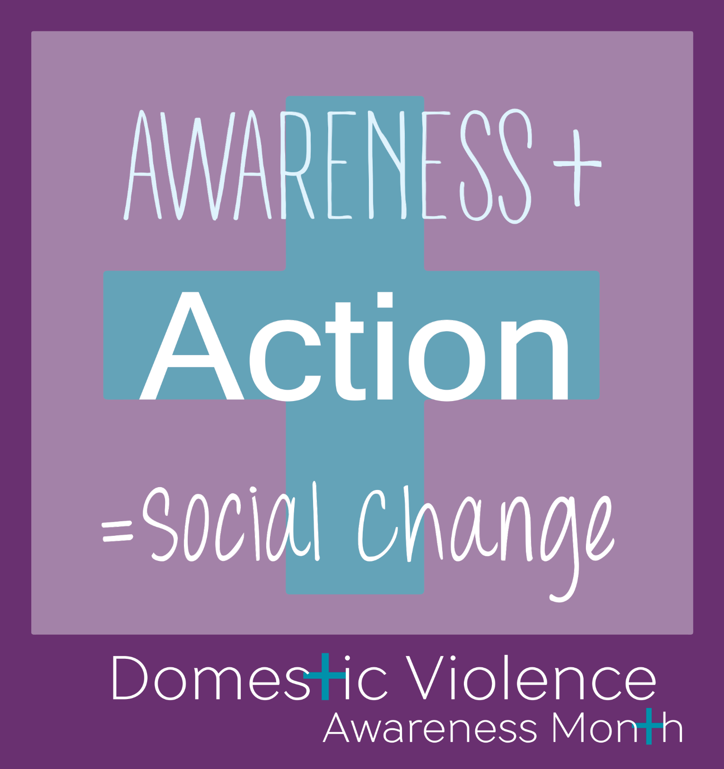

Resources:

On Campus

974-HELP – Dean of Students
413 Student Services Building
1331 Circle Park
Knoxville, TN 37916
865-974-4357

974-HELP is a help line for distressed students. It is available 24hrs a day. If you are concerned or worried for a fellow Vol, observe a behavior that makes you uncomfortable, or you feel like a fellow Vol may harm themselves or others, 974-HELP is where you can call for support. Students can also call 974-HELP for themselves. (It is not a resource for immediate emergencies. Contact 911 or UTPD at 865-974-3111 for emergencies.)

Center for Health Education & Wellness
Student Health Building, 2nd Floor
1800 Volunteer Blvd
Knoxville, TN 37996
M -F: 8:00am – 5:00pm
https://wellness.utk.edu/healthy-relationships/

The Center for Health Education & Wellness (CHEW) provides education and information on healthy relationships.

Office of Title IX
1817 Melrose Ave
Knoxville, TN 37996
865-974-9600
https://titleix.utk.edu/

The Office of Title IX provides support to students who may be experiencing an issue related to Title IX. Their
website is where you can find the full Policy on Sexual Harassment, Sexual Assault, Dating and Domestic Violence and Stalking, their You Are Not Alone guide, Respondent Support guide, and on-campus and community resources related to sexual assault and other forms of interpersonal violence.

Student Counseling Center
Student Health Building, 2nd Floor
1800 Volunteer Blvd
Knoxville, TN 37996
865-974-2196

The Student Counseling Center provides individual sessions, group therapy, and couple’s therapy.

UT Police Department (UTPD)
911
865-974-3114

Off Campus

Family Justice Center (FJC)
865-521-6336 (24/7 hotline)
https://fjcknoxville.com/

The FJC assists survivors of both domestic abuse and sexual violence.

Helen Ross McNabb Sexual Assault Center of East Tennessee (SACET)
2455 Sutherland Avenue, Building B, Knoxville, TN 37919
865-522-7273 (24/7 hotline)

The SACET provides sexual assault nurse examinations, prophylactic STD and ECP medications, baseline STD testing, expert witness testimony in court, advocacy, therapy, education, and outreach. All services are FREE.
UTPD will provide transportation for UT students to the SACET. You do not have to report to the police to receive transportation services.

Domestic Violence Awareness Project
https://www.dvawareness.org/

National Domestic Violence Hotline
https://www.thehotline.org/

Sources

Centers for Disease Control and Prevention. (2020, April 30). Violence prevention infographics. Retrieved from https://www.cdc.gov/violenceprevention/communicationresources/infographics/index.html

National Domestic Violence Hotline. (n.d.). What is domestic violence. Retrieved from https://www.thehotline.org/is-this-abuse/abuse-defined/

