Consent

What is Consent?

The UT Policy on Sexual Harassment, Sexual Assault, Dating and Domestic Violence and Stalking defines consent as an active agreement to participate in a sexual act.

Sexual consent might be touching, kissing, oral, vaginal, or anal sex. Getting consent before any sexual activity
means you both are sure that everyone wants to participate. Consent can help make sex enjoyable for everyone and ensures that everyone can say yes to what they want.

Doing something sexual to another person without their consent is sexual assault.

Consent Considerations
You can think about consent by asking yourself the following:

- Did you and a partner both agree to sex?
- Did you both agree to every sexual activity?
- Did you feel you could say no to anything you didn't want to do? Could the person you were
with say no?
- Is the activity what you wanted to do? What about your partner?

Giving and Withholding Consent
You can express what you want or don't want through words, body language, hand gestures or facial expressions.
If you're not sure if a partner is consenting, ASK!
Either person can withdraw consent at any time.
Even if you said yes at first, it's always OK to stop if you change your mind.
If a partner changes their mind or says they don't want to keep going, respect their choice and stop.
Even if you consented before, it doesn't mean you consent to do it again.
Just because you consent to one sexual activity doesn't mean you've consented to every sexual activity.

How Can You Tell You Have Consent?

Consent can sound like and look like…

- Verbal:
  - Yes!
  - I'm sure
  - Don't stop
  - OMG, yes!
  - That feels good
  - I want this
  - I'm ready
- Non-verbal:
  - Direct eye contact
  - Pulling someone closer
  - Nodding
  - Relaxed facial expression
  - Seems comfortable

Not having consent can sound like and look like…

- Verbal:
  - No
  - I'm not sure
  - Stop
  - I want to, but . . .
  - That hurts
  - Maybe
  - I don't know
  - I want this, but not right now
- Non-verbal:
  - Avoiding eye contact
  - Pushing someone away
  - Seems checked out
  - Tense, stiff
  - Seems uncomfortable
  - Silence

If you hear or see these things, pause and check in with your partner. Ask them what they would like to do or would be comfortable with. Give them time and space to reply honestly. The answer may be that they do not want to have sex, or maybe they would like to express intimacy in another way. Whatever their response is, it is important to respect their boundaries.

Images You Can Use:
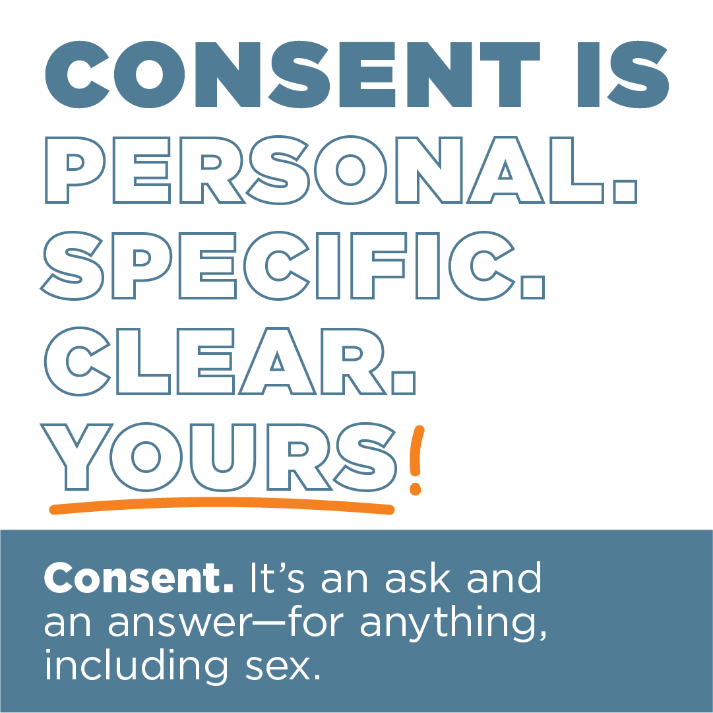
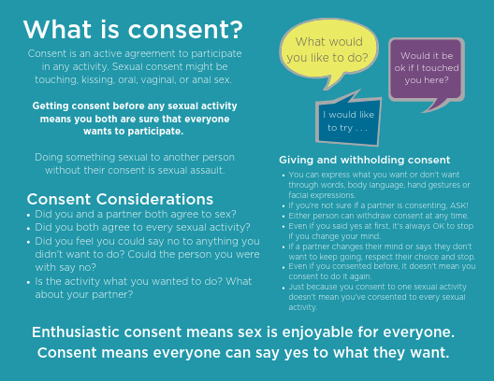

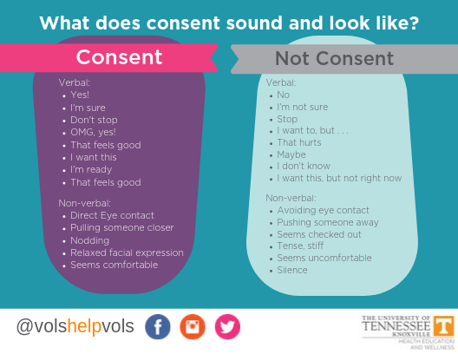

Resources:

Center for Health Education & Wellness
Student Health Building, 2nd Floor
1800 Volunteer Blvd
Knoxville, TN 37996
M -F: 8:00am – 5:00pm
https://wellness.utk.edu/consent/

The Center for Health Education & Wellness (CHEW) webpage on consent provides more information on consent and several resources to learn more about consent.

Office of Title IX
1817 Melrose Ave
Knoxville, TN 37996
865-974-9600
https://titleix.utk.edu/

The Office of Title IX provides support to students who may be experiencing an issue related to Title IX. Their

website is where you can find the full Policy on Sexual Harassment, Sexual Assault, Dating and Domestic Violence and Stalking, their You Are Not Alone guide, Respondent Support guide, and on-campus and community resources related to sexual assault and other forms of interpersonal violence.

