Cold & Flu Prevention
What is Cold and Flu
Cold or Flu? What’s the Difference?
It can be hard to tell the two apart. Both the common cold and flu are respiratory illnesses. They are also both caused by viruses. Generally, flu symptoms are more severe than cold symptoms. The flu can also result in complications such as pneumonia, bronchitis, sinus infections and ear infections. The common cold does not result in severe complications.
COVID-19 (another illness caused by a virus) makes it a little harder to recognize the difference between these common illnesses. The chart below outlines the signs and symptoms of each of these illnesses.
Flu vs. Cold vs. COVID-19: Signs and Symptoms
Signs and Symptoms | Influenza | Cold | COVID-19
Symptom onset | Abrupt | Gradual | Soon or gradual; 2 days – 14 days after infection
Fever | Usual; lasts 3-4 days | Rare | Often
Aches | Usual; often severe | Slight | Often
Chills | Fairly common | Uncommon | Fairly common
Fatigue, weakness | Usual | Sometimes | Usual
Sneezing | Sometimes | Common | Rarely
Stuffy nose | Sometimes | Common | Sometimes
Sore throat | Sometimes | Common | Sometimes
Chest discomfort, cough | Common; can be severe | Mild to moderate; hacking cough | Common
Headache | Common | Rare | Sometimes
Vomiting | Sometimes | Rare | Sometimes
Diarrhea | Sometimes | Rare | Sometimes
Loss of sense of taste or smell | Rare | Rare | Sometimes
Shortness of breath or difficulty breathing | Sometimes | Mild | Common

Preventing Cold and Flu
- Wash your hands often with soap and water.
If soap and water are not available, use an alcohol-based hand sanitizer. Viruses that cause illnesses can live on your hands, and regular handwashing can help protect you from getting sick.
- Avoid touching your eyes, nose, and mouth with unwashed hands.
- Try to avoid close contact with sick people. (Close contact includes things like sharing food or drinks and kissing.)
- Cover your nose and mouth with a tissue when you cough or sneeze and throw the tissue away.
- Clean and disinfect surfaces and objects that may be contaminated.
Flu Shots
- The best way to prevent the flu is by getting a flu shot. If you get a flu shot, but still get the flu, the symptoms can be less severe.
- It is recommended to get a flu shot every year, even if you are a healthier adult.
- Flu shots help prevent you from getting the flu and helps prevent the flu from spreading to others.

Treating Cold and Flu
- Stay at home and rest. Even though it’s tempting to power through class or go to work, rest is important to getting over your illness.
- There is no cure for cold or flu. Choose over-the-counter medications that match your symptoms but limit the number of medications you’re taking.
- Always read the labels on over-the-counter medications and use as directed.
When to be seen by a Doctor – Cold
If you’re experiencing one or more of these symptoms
- A temperature higher than 100.4° F
- Symptoms that last more than 10 days
- Symptoms that are severe or unusual
When to be seen by a Doctor – Flu
Emergency warning signs of flu sickness includes
- Difficulty breathing or shortness of breath
- Pain or pressure in the chest or abdomen
- Sudden dizziness
- Confusion
- Severe or persistent vomiting
- Flu-like symptoms that improve but then return with fever and worse cough

Images You Can Use
World Health Organization – Handwashing chart
(Source: https://www.who.int/gpsc/clean_hands_protection/en/)
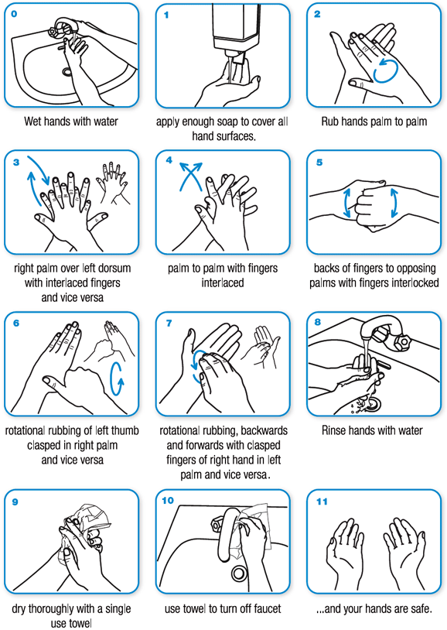
Resources
Handwashing Fact Sheets
https://www.cdc.gov/handwashing/pdf/wash-your-hands-fact-sheet-508.pdf
https://www.cdc.gov/handwashing/pdf/hand-sanitizer-factsheet.pdf
“Wash Your Lyrics” Poster Generator
https://washyourlyrics.com/
Student Health Center
Student Health Building, 1st Floor
1800 Volunteer Blvd
Knoxville, TN 37916
M, T, Th, F: 8:00am – 5:00pm
W: 9:00am – 5:00pm
Colds and flu typically don’t require a doctor’s visit, but if you think you might be at high risk for complications or have concerns, contact the Student Health Center Triage Nurse 865-974-5080. Additionally, if you think your illness may be COVID-19, you can also contact the Student Health Center Triage Nurse.
Student Health Center Pharmacy
Student Health Building, 1st Floor
1800 Volunteer Blvd
Knoxville, TN 37916
M, T, W, Th, F: 10:00am – 4:00pm
The on campus pharmacy offers flu shots. The pharmacy also sells over-the-counter medications. Contact the pharmacy at 865-974-5932.

Sources
Centers for Disease Control and Prevention. (2016, August 01). CDC Says “Take 3” Actions to Fight the Flu. Retrieved from http://www.cdc.gov/flu/protect/preventing.htm
Centers for Disease and Prevention. (2019, December 30). Cold Versus Flu. Retrieved from https://www.cdc.gov/flu/symptoms/coldflu.htm
Centers for Disease and Prevention. (2017, February 06). Common Colds: Protect Yourself and Others. Retrieved from https://www.cdc.gov/features/rhinoviruses/index.html
Centers for Disease Control and Prevention. (2017, March 01). Flu Symptoms & Complications. Retrieved from https://www.cdc.gov/flu/consumer/symptoms.htm
Centers for Disease Control and Prevention. (2016, August 18). The Flu: What To Do If You Get Sick. Retrieved from http://www.cdc.gov/flu/takingcare.htm
Centers for Disease Control and Prevention. (2020, July 10). Similarities and Differences between Flu and COVID-19. Retrieved from https://www.cdc.gov/flu/symptoms/flu-vs-covid19.htm

