Volunteers Speak Up! Be an ACTive Bystander
Defining Being an Active Bystander
At the University of Tennessee, Volunteers Speak UP! by being an active bystander. Bystander: Sees a potentially harmful situation and doesn’t intervene.

As a bystander, we may:
- Think it is none of our business
- Hope that someone else will deal with it
- Miss an opportunity to change the community we live in for the better

Active Bystander: Sees a potentially harmful situation and intervenes SAFELY to reduce or remove that harm. An active bystander is a person who takes the steps that can make a difference.

As an active bystander, we may:
- Positively impact the individuals we are concerned about
- Become a role model for others to have confidence to speak up
- Create a community that values taking care of one another

Steps to Being an Active Bystander

Being an ACTive bystander is as easy as ACT!
- Acknowledge the situation: when something doesn’t feel right, it probably isn’t!
- Consider your options: what can you safely do to intervene?
- Take ACTion: Be Direct, Delegate or Distract!

How Can You ACT?
Below are some examples of possible statements or actions to use if you see a situation that is concerning and feel that you can safely intervene. Remember you can always ask a fellow Vol to help. It is easier to intervene with a friend.

- Distract: Make up a reason to distract the people involved in the situation. This action can help you get more information about what is going on and diffuse potential harm.
  - “Hey aren’t you in my psych class? I need to talk about the mid-term.”
  - “Oh, hey, do you know where the bathroom is?”
  - Spill something and ask for help cleaning up.
- Delegate: When the situation seems too difficult for you to intervene safely, delegation is still intervening!
  - If someone is in a life-threatening situation, 911!
  - At a party, you can ask the host for help.
  - RA’s, TA’s, and other university representatives are resources in place to help you if you have concerns.
- Direct: When it is safe to just directly say what’s going on and what should happen next.
  - “Whoa, that’s not ok, please stop.”
  - “I think you’ve had too much, let me get you home.”
  - “Hey, I’m heading out. Why don’t you come with me? We’ll get that person’s number and you can call them tomorrow.”

Images You Can Use:

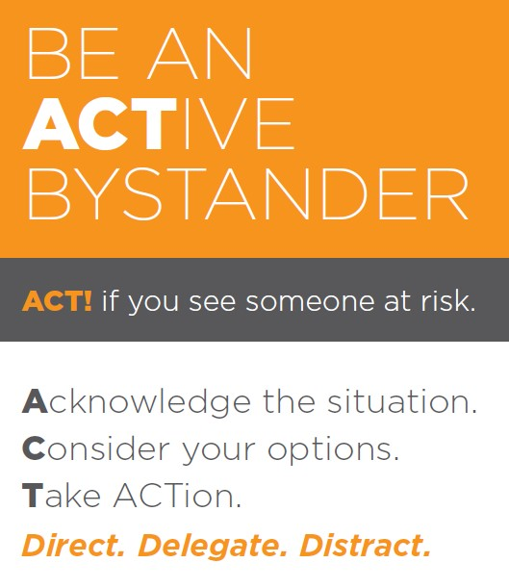

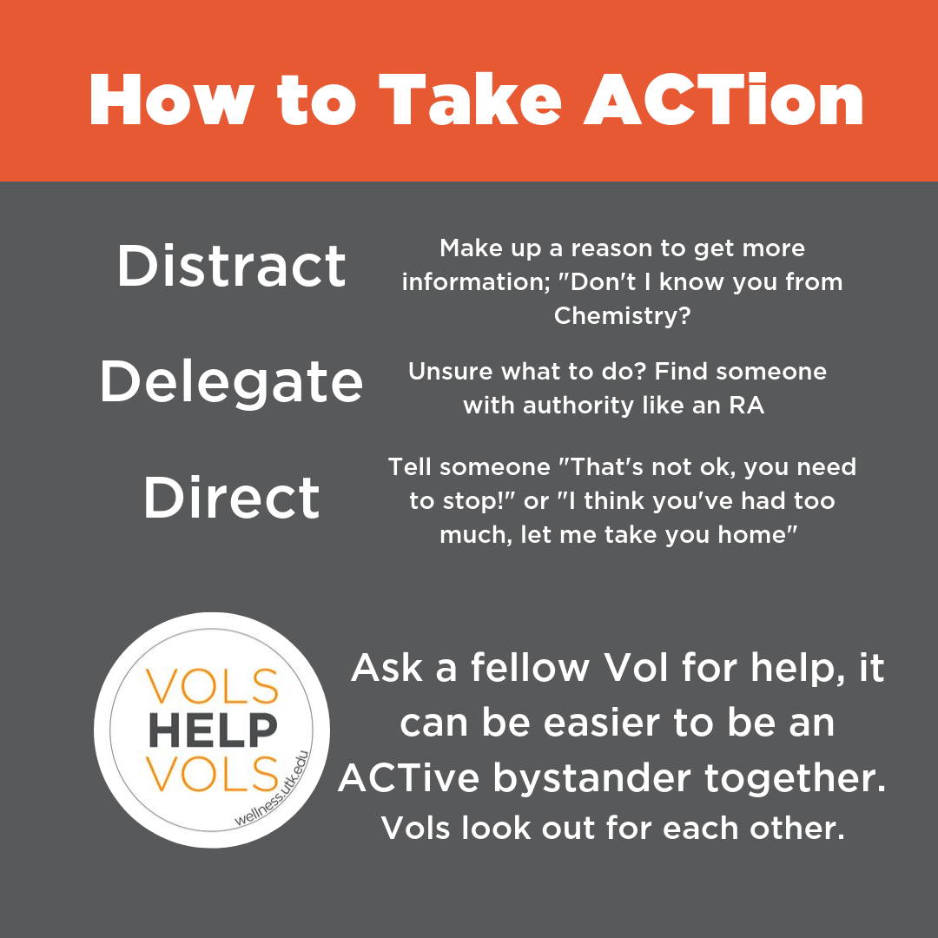

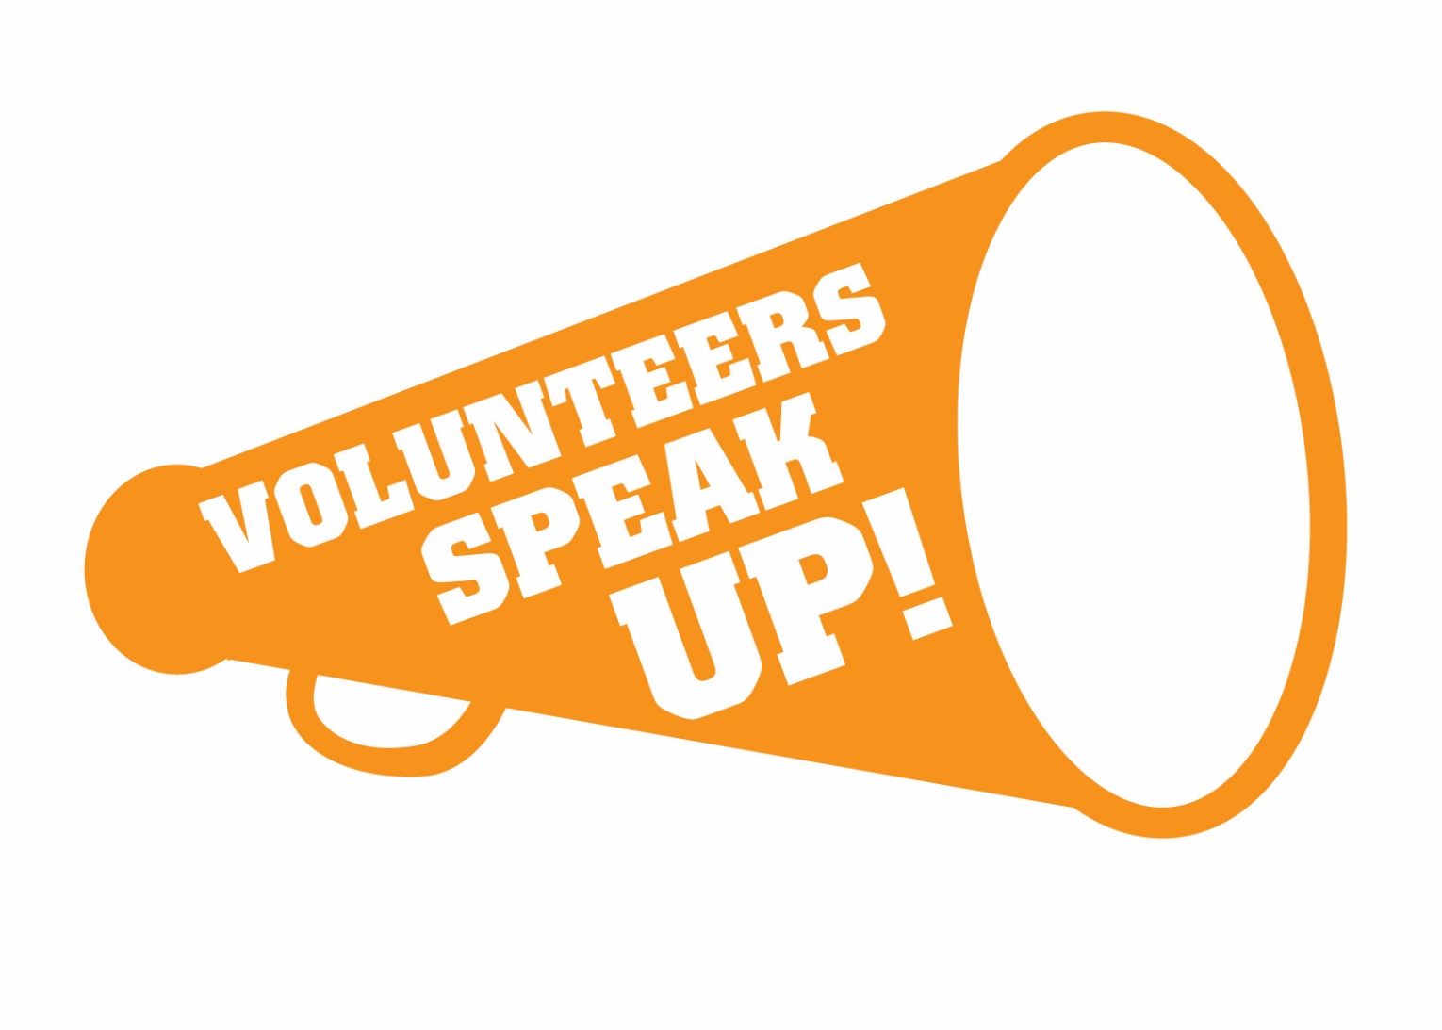

Resources:

Arizona State University’s Step UP! Strategies for Effective Helping
https://stepupprogram.org/students/strategies-for-effective-helping/

Student Conduct & Community Standards

The Student Code of Conduct has a Policy on Amnesty for Individual Good Samaritans and Students in Need of Emergency Medical Attention found on page 24
https://studentconduct.utk.edu/wp-content/uploads/sites/53/2018/07/460805-StudentCodeOfConductBook-FINALaccessiblePAGES1.pdf

Hazing Prevention

https://hazingprevention.utk.edu/

UT’s hazing prevention website describes way to intervene and prevent hazing on campus.

